#### **MongoDB Task - Week 12**

#### **Create Operation**

**Q:** Create a new database named "library" and switch to it.  
**A:** use library

**Q:** Create a collection named "books" with fields: title, author, and published_year.

**A:** db.books.insert({title: "The Great Gatsby", author: "F. Scott Fitzgerald", published_year: 1925

})

**Q:** Insert a document into the "books" collection with the details of your favorite book.  
**A:** db.books.insertMany([{ title: "The Alchemist", author: "Paulo Coelho", year: 1988 },{ title: "Animal Farm", author: "George Orwell", year: 1945 },{ title: "The Hobbit", author: "J.R.R. Tolkien", year: 1937 },{ title: "Little Women", author: "Louisa May Alcott", year: 1868 }])

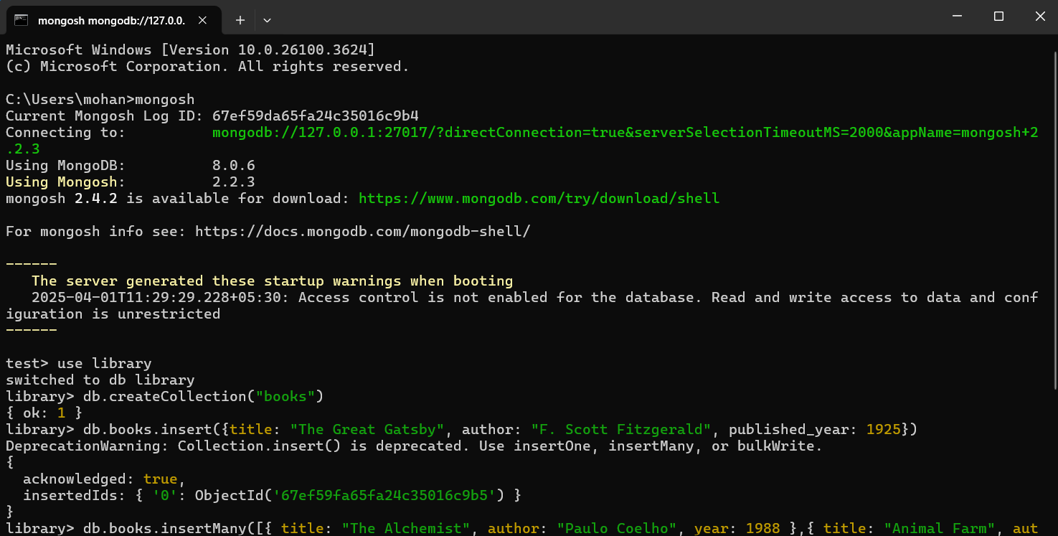  
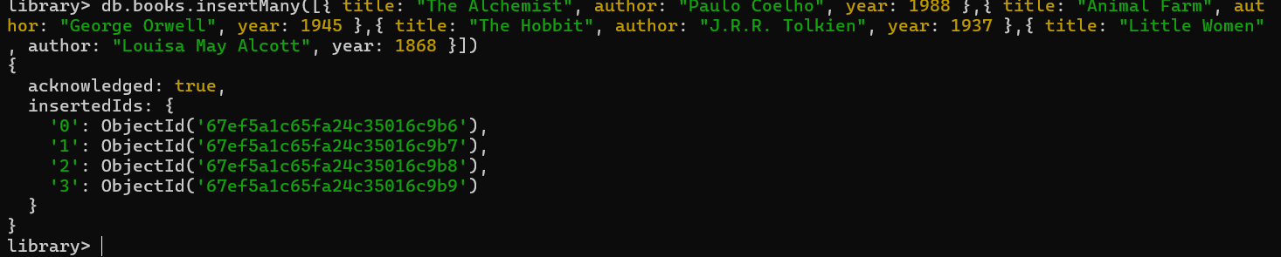

#### **2. Read Operation**

**Q:** Retrieve all documents from the "books" collection.  
**A:** db.books.find()

**Q:** Find and display only the documents where the author is "Paulo Coelho"..  
**A:** db.books.find({ author: "Paulo" })

**Q:** Fetch and display the document with the earliest published year.  
**A:** db.books.find().sort({ year: 1 }).limit(1)

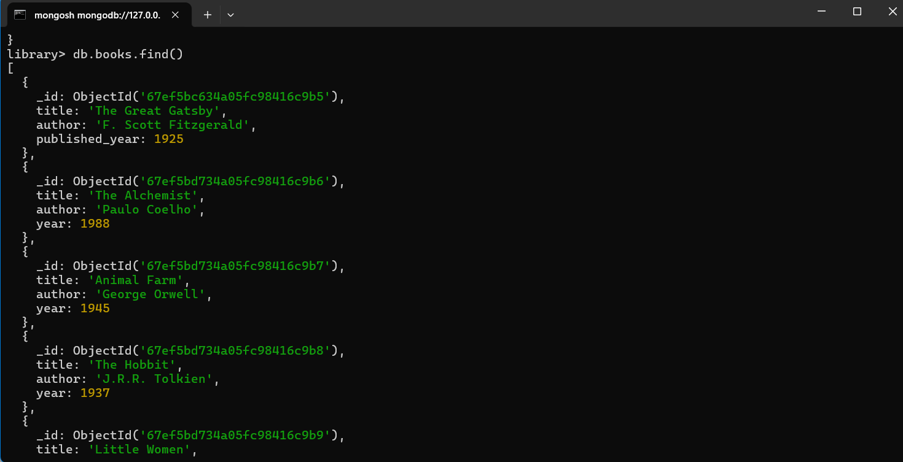

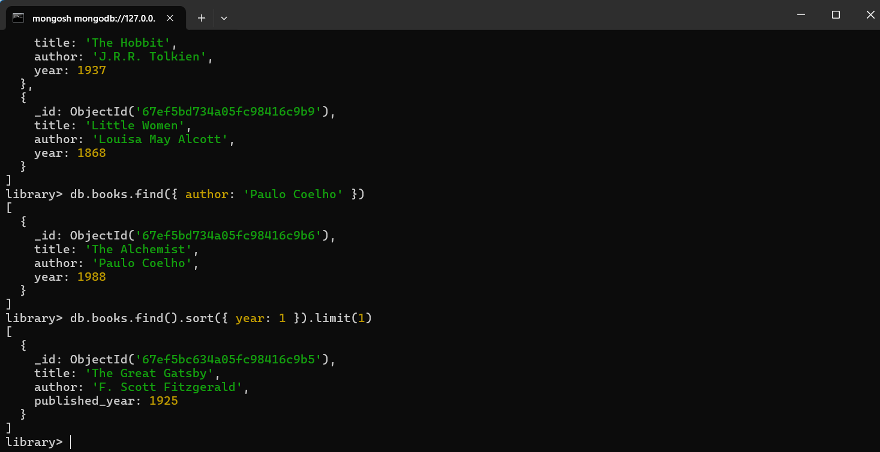

#### 

#### **3. Update Operation**

**Q:** Update the published year of the book with the title "Little Women" to the current year.  
**A:** db.books.updateOne({ title: "Little Women" }, { $set: { year: new Date().getFullYear() } })

**Q:** Add a new field "genre" with the value "Mystery" to the books "Little Women". **A:**db.books.updateOne({ title: "Little Women" }, { $set: { genre: "Fiction" } })

**Q:** Verify the update for "Little Women".  
**A:** db.books.find({ title: "Little Women" })

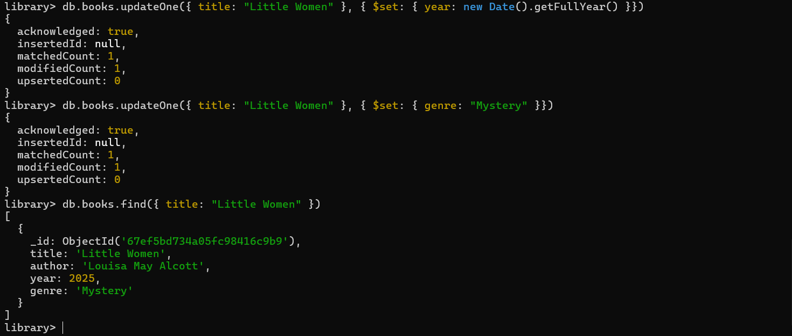

#### **4. Delete Operation**

**Q:** Remove the document with the title "Little Women" from the "books" collection.  
**A:** db.books.deleteOne({ title: "Little Women" })

**Q:** Delete all documents from the "books" collection where the published year is before 1950.  
**A:** db.books.deleteMany({ year: { $lt: 1950 } })

**Q:** Verify the remaining documents in the collection.  
**A:** db.books.find()

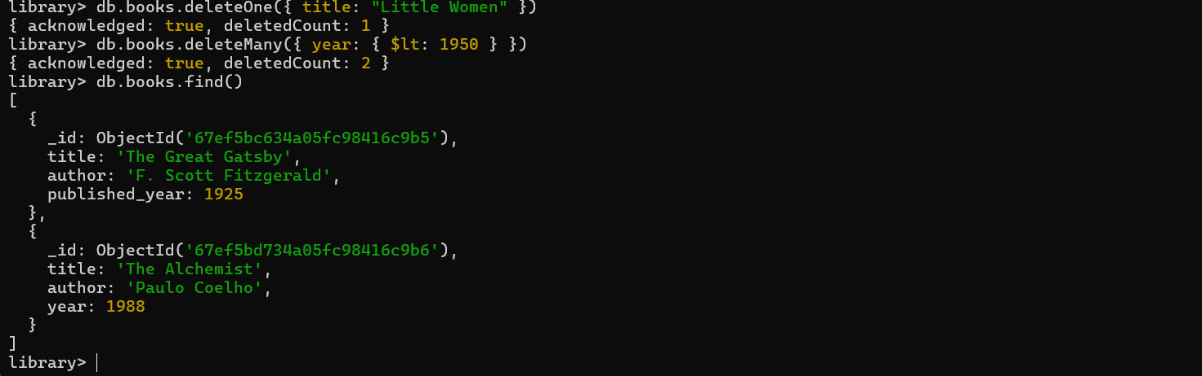

#### **5. Advanced Query**

**Q:** Find and display the top 3 recently published books from the "books" collection.  
**A:** db.books.find().sort({ year: -1 }).limit(3)

**Q:** Retrieve documents from the "books" collection where the title contains the word "MongoDB" or "NoSQL".  
**A:** db.books.find({ title: { $regex: "(MongoDB|NoSQL)" } })

**Q:** Retrieve documents where the title contains the word "The".  
**A:** db.books.find({ title: { $regex: "(The)" } })

